**Chapter 11 - Loops**

Loops are the fundamentals to work with the lists. Its primary purpose is to iterate.

* Arrays are iterable but object is not iterable.

**Types of loops in javascript:**

* **For**
* **For…of**
* **For…in**
* **While**
* **do…while**

**If..else:**

**Syntax:**

if(condition)

{

Stmt1; // this will be executed if the condition is true.

Stmt2;

}

Else

{

Stmt; // this will be executed if the condition is false.

}

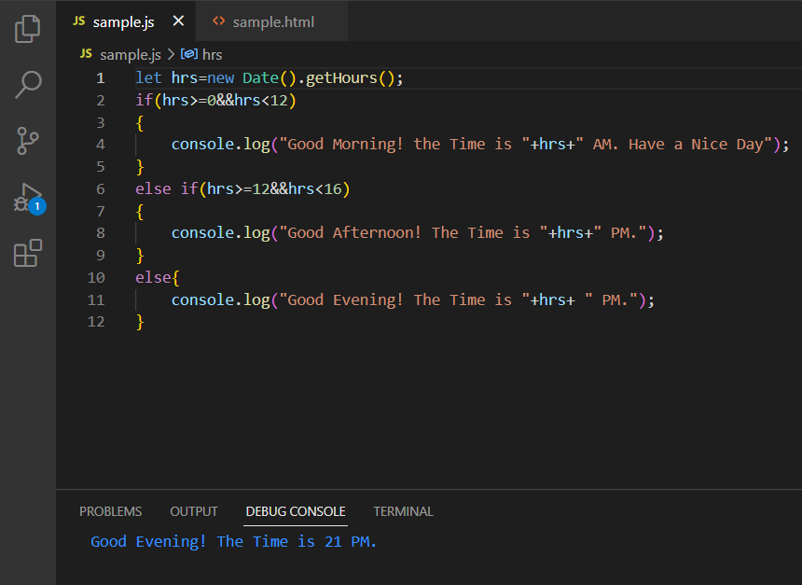

**Switch…case:**

The switch..case statement is used to select one of many code blocks to be executed.

**Syntax:**

switch(expression){

Case x:

// code block

Break;

Case y:

//code block

Break;

Default:

//code block

}

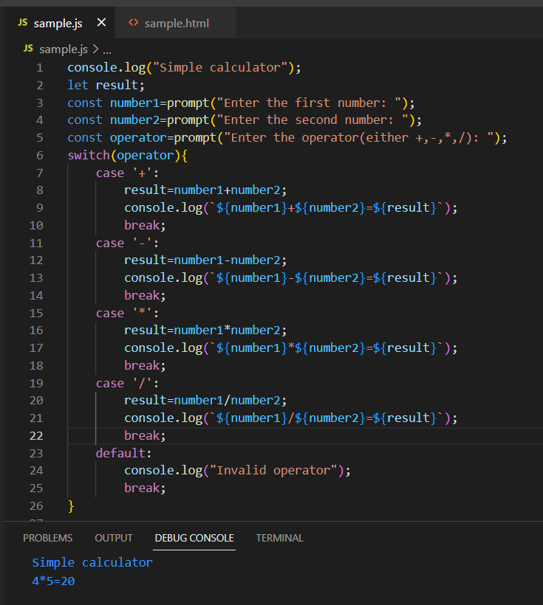

If the break statement is not present in the case block the execution will takes place for the next case block also. When all the condition fails the default block will be executed.

**For loop:**

Syntax:

for(initialization;condition;increment/decrement)

{

Stmt

}

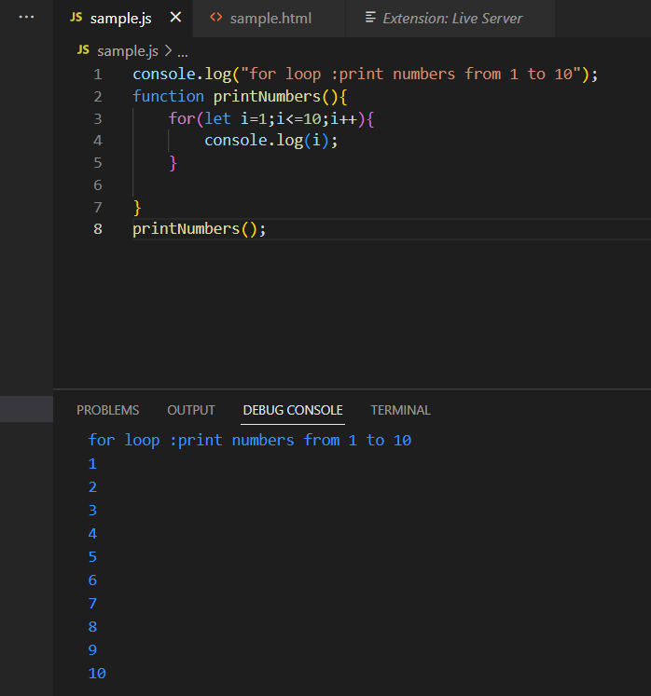

**Nested for loop:**

The nested for loop is used for 2D array.

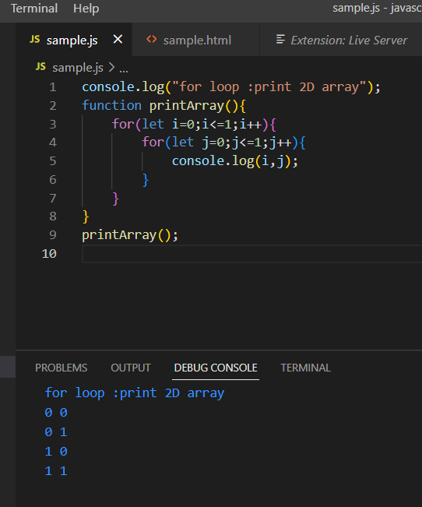

**The Infinite for loop:**

Syntax:

for(;;)

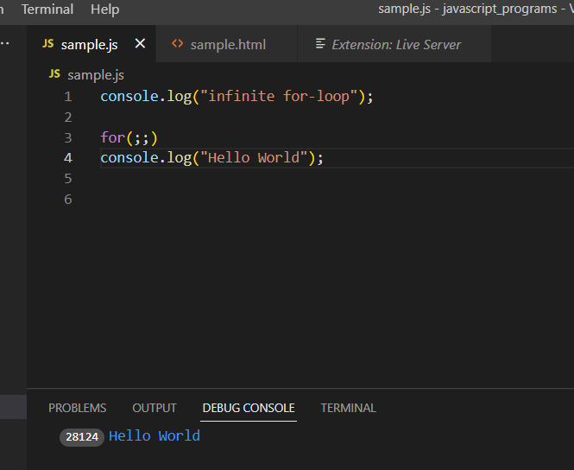

**Break:**

This statement is used to exit the loop and moves to next statement for execution.

**Continue:**

This statement is used to skip that part of execution in the loop and moves to starting point of the loop for next iteration.

**Breaking to label:**

This is the label name prepended to a statement. In case of nested for loop this label is used to identify the loop.

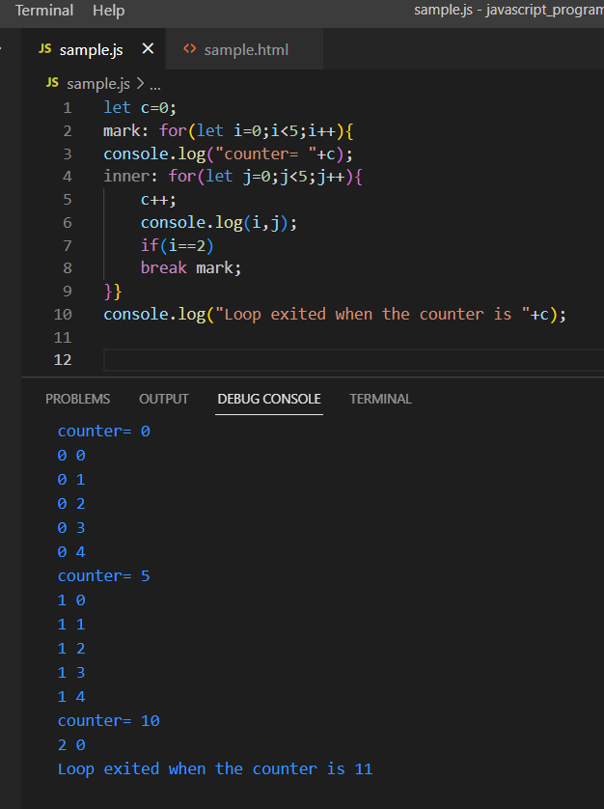

This label is used not only for for loops but also for non for-loop block scope.

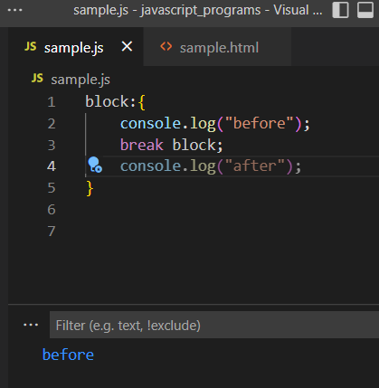

**For..of loops:**

The for..of statement creates a loop iterating over iterable objects, including: string, array, map, set.

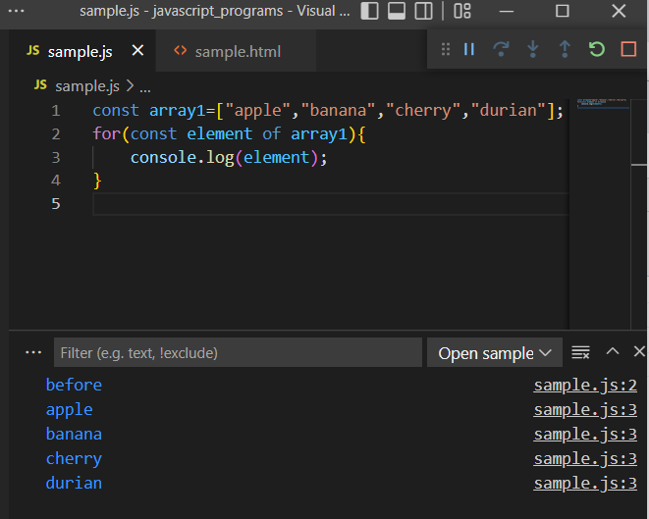

Here the values in the array gets displayed.

**For…of and strings**:

When used with strings it displays the every character present in the one by one.

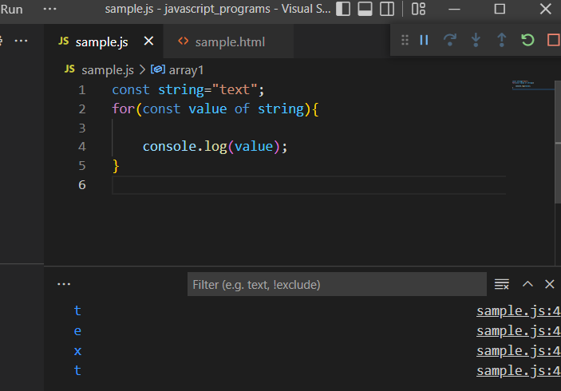

**For..of and maps:**

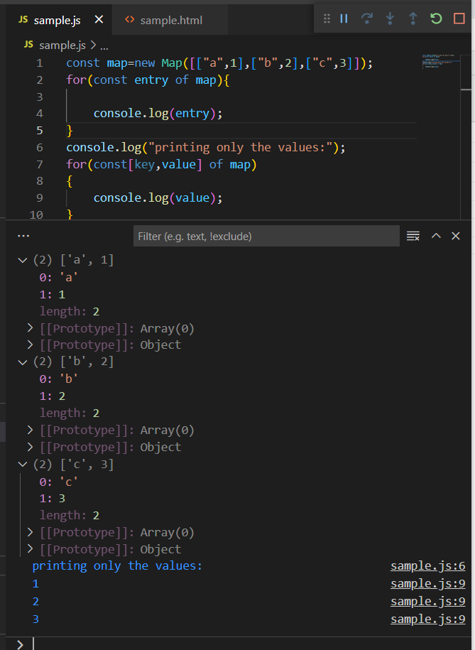

**For..of and set:**

Here it displays the values present in the set but duplication of values is not allowed.

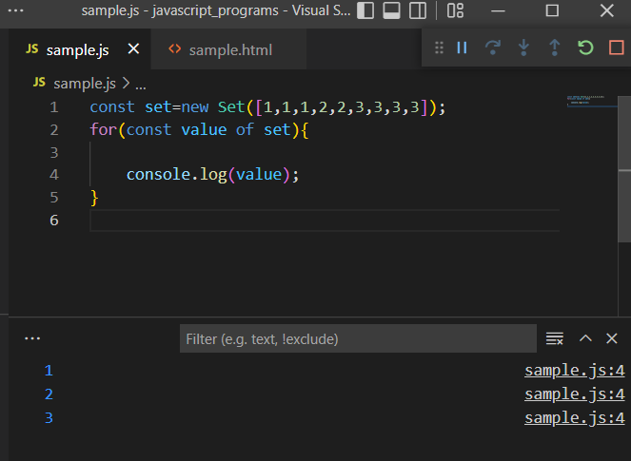

**For..of and generators:**

Generator is a special type of function with star * attached to the function keyword (function*)

The generator function will execute until it encounters the yield keyword.

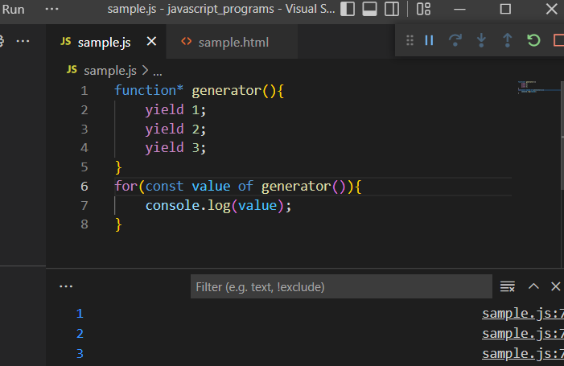

The above code can be executed manually as follows:

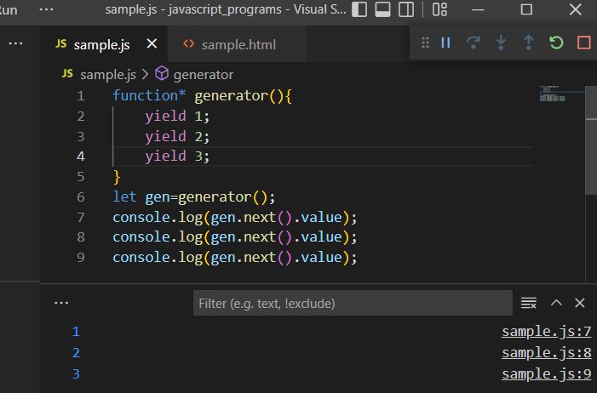

**For..of and object:**

for ..of loops work for iterable values. It does not work for objects.

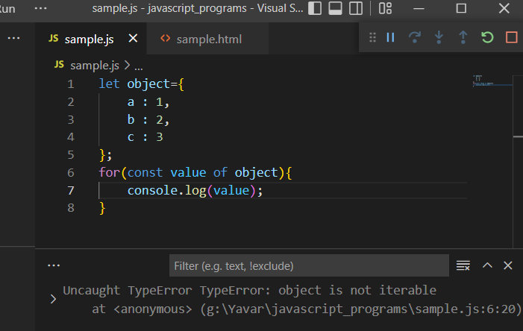

To avoid this problem, the object must be converted to iterable using the built-in object methods like .keys, .values or .entries.

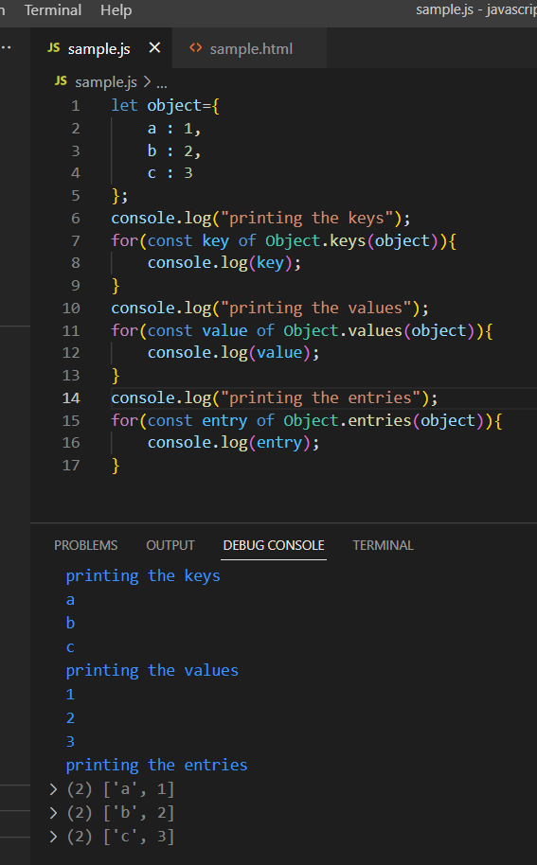

**For..in loops:**

To avoid the confusion in converting the objects to iterables, this can be directy iterated by using for..in loops.

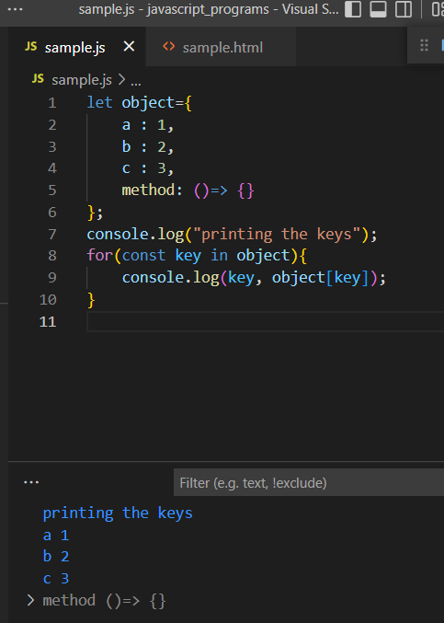

**While loops**:

This loop will iterate for indefinite number of times until the specified condition evaluates to false.

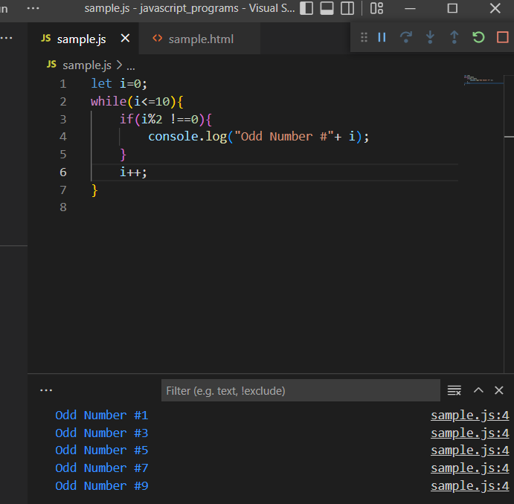

**Do..while loop:**

This loop will executed atleast once before the condition is checked.

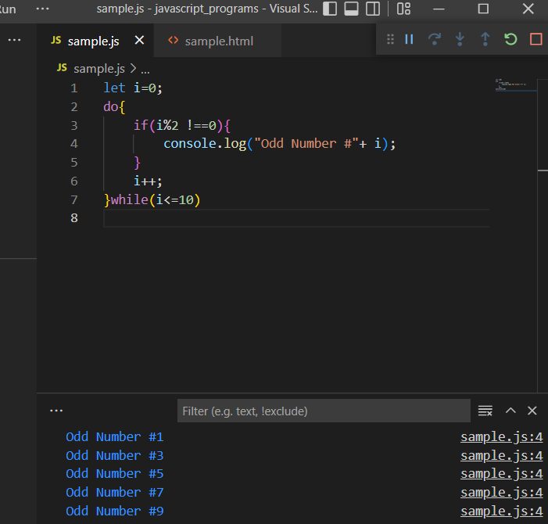

**While and break:**

The break keyword is used to exit the loop when the condition is satisfied.

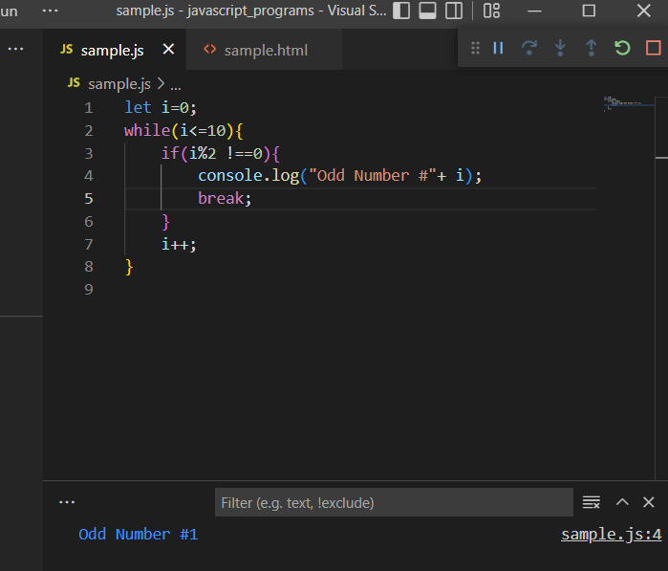

**While and continue:**

The continue keyword is used to skip that particular iteration and move to beginning of the loop for the next iteration.

